Selenium to Playwright Converter – n8n Workflow
Issues Identified, Resolutions and Key Takeaways
Purpose. This document records the key issues encountered while building and testing the Selenium-to-Playwright conversion workflow in n8n, the resolution applied for each issue, and the practical lessons learned for future workflow development and troubleshooting.

Framework

Main workflow

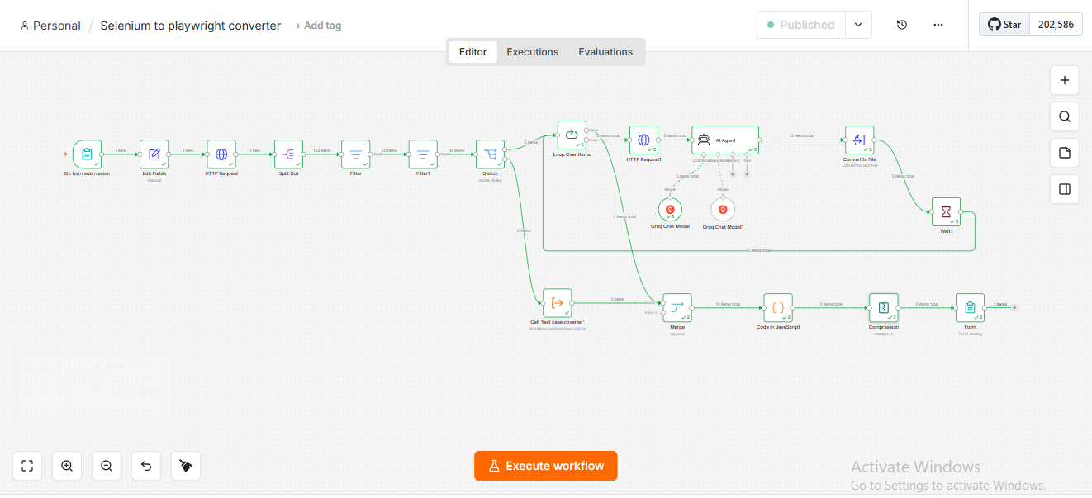

Sub workflow

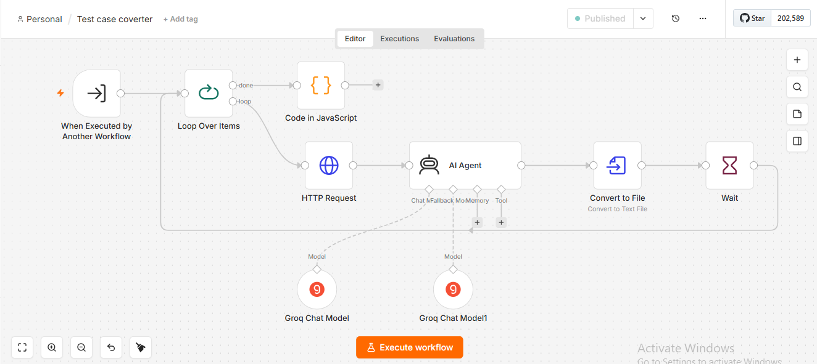

Output file after migration

Issues Encountered and Resolutions

HTTP Request1 was not executed
- Issue: n8n displayed “Node was not executed” because the execution path did not reach HTTP Request1.
- Root Cause / Analysis: The workflow path was traced backward from HTTP Request1. The Loop Over Items node was found to be connected through the wrong output.
- Resolution: HTTP Request1 was connected to the loop output of Loop Over Items so that each incoming item could be processed.
- Key Takeaway: A node showing “not executed” is not necessarily faulty; first verify that the execution path actually reaches the node.

Loop Over Items had no loop output connection
- Issue: The Loop Over Items node indicated that no node was connected to its loop output.
- Root Cause / Analysis: The downstream HTTP Request1 node was not connected to the loop branch.
- Resolution: The connection was changed to Loop Over Items → loop → HTTP Request1.
- Key Takeaway: Understand the purpose of the loop and done outputs. The loop output processes items; the done output is used after the loop completes.

Switch rule did not route page files
- Issue: The Switch rule used “is equal to /pages”, while the actual GitHub path was a complete file path containing /pages, such as a Java file path under the pages directory.
- Root Cause / Analysis: The condition was comparing the entire path with the short directory value.
- Resolution: The routing condition was changed from “is equal to” to “contains”, with /pages retained as the matching value.
- Key Takeaway: For hierarchical file paths, “contains” can be more appropriate than exact equality when the target directory appears within a longer path.

Test-case branch was not routing correctly
- Issue: The test-case routing rule also used exact equality for /testcases, so full test-case file paths were not matched.
- Root Cause / Analysis: The same path-matching issue existed in the second Switch rule.
- Resolution: The rule was changed from “is equal to” to “contains”, using /testcases as the matching value.
- Key Takeaway: Use routing conditions that reflect the actual structure of incoming data rather than assuming the field contains only the directory name.

Sub-workflow item-processing mode needed adjustment
- Issue: The test-case branch needed to process incoming test-case files individually.
- Root Cause / Analysis: The Execute Sub-workflow node was configured to process one incoming item at a time.
- Resolution: The execution mode was changed to “Run once for each item”.
- Key Takeaway: Choose between processing all items together and processing each item individually based on the data-processing requirement.

Convert to File reported that Output was not set
- Issue: The Convert to File node expected a field named Output, while the AI Agent returned the field as output.
- Root Cause / Analysis: The field-name mismatch was identified.
- Resolution: The Text Input Field was changed from Output to output.
- Key Takeaway: n8n field names are case-sensitive. Always verify the exact field name and structure produced by the previous node.

JavaScript Code node reported an unexpected '&' token
- Issue: The JavaScript contained HTML-encoded/escaped characters such as &#x20; and escaped brackets, which are invalid in the intended JavaScript syntax.
- Root Cause / Analysis: The actual code content was inspected rather than changing the workflow logic.
- Resolution: The corrupted characters were replaced with clean JavaScript syntax while preserving the intended logic for merging binary inputs.
- Key Takeaway: When a syntax error appears unexpectedly, inspect the literal characters in the code. Copy/paste or formatting transformations can introduce invalid characters.

Compression node could not identify the binary fields
- Issue: The expression used to obtain the binary field names was being interpreted as text instead of as an n8n expression.
- Root Cause / Analysis: The Input Binary Field(s) configuration was checked.
- Resolution: Expression mode was enabled so that {{ Object.keys($binary).join(',') }} was evaluated dynamically.
- Key Takeaway: In n8n, distinguish clearly between literal values and expressions. Expressions must be entered/evaluated in Expression mode.

ZIP contained an AI request for source code instead of converted content
- Issue: The Test Case Converter AI reported that it needed the Java test-case source code. The HTTP Request node responsible for retrieving the source file was deactivated.
- Root Cause / Analysis: The sub-workflow execution and node status were inspected.
- Resolution: The deactivated HTTP Request node was enabled, allowing the Java source content to reach the conversion flow.
- Key Takeaway: If an AI node says it is missing input, check upstream data-retrieval nodes and confirm that they are active and actually executed.

Overall Debugging Takeaways

Trace the data path:
When a node fails or is skipped, first determine whether the expected input actually reached that node.

Validate each node independently:
Execute upstream nodes and inspect their output before changing downstream configuration.

Check exact field names:
Confirm spelling, capitalization, nesting and data type of fields referenced in expressions.

Understand n8n routing:
Switch, Filter and Loop Over Items determine which path receives the data. Incorrect routing can make downstream nodes appear broken.

Use sub-workflows for modularity:
Separate page conversion, test-case conversion and other responsibilities when the solution becomes complex.

Verify node status:
A deactivated node can silently prevent required data from reaching the next stage.

Test incrementally:
Make one change, execute the affected section, confirm the result, and then proceed to the next step.

Final Workflow Learning
The main lesson from this implementation is: debug the workflow by following the data from node to node. For each stage, confirm three things: Is the node being reached? Is the expected data entering it? Is it producing the expected output? Once these checks are performed systematically, most n8n workflow issues can be isolated without changing multiple nodes at the same time.

